**Article ID:** [4208] How to clean the filters of my dishwasher.

**Article name:** How to clean the filters of my dishwasher

**Topic location:** Dishwasher / Cleaning & Maintenance

**Metadata:** dirt

**RFC:**

**Related articles:**

**Related questions:**

PNC

DIY

Safety

Link

Email

Book Engineer

Multimedia

Brand

**Article content:**

**WSS**

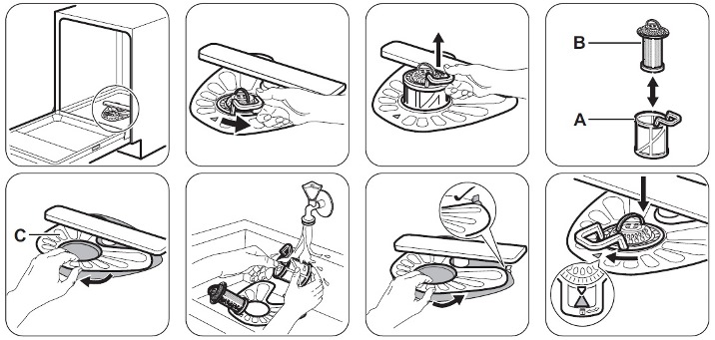

http://services.electrolux-medialibrary.com/bild.php?src=ehppdb-pictures/G/B/JPEG/PSGBDL140G002010.jpg

Make sure that there are no food or soil residues in or around the edge of the sump.

Put the flat filter (C) back in place. Make sure that it is positioned correctly under the 2 guides.

Reassemble filters (A) and (B).

Put filter (A) back into flat filter (C). Turn it clockwise until it locks.

An incorrect filter position can cause poor washing results and damage to the appliance.

Please refer to your User Manual for further assistance.